Mailing Client:

We don’t use python script to directly send emails, instead we use python script to log into the email server and use SMTP protocol from there.

The libraries:

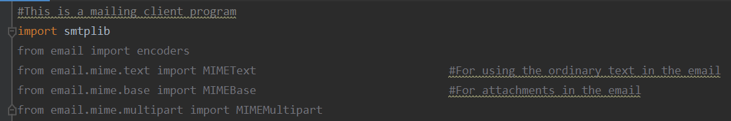

So, first defining the server with the domain and port number and then with server.ehlo() as the function to start the server. My suggestion is to encrypt the .txt file with your password and then decrypt it and use it in the email script.

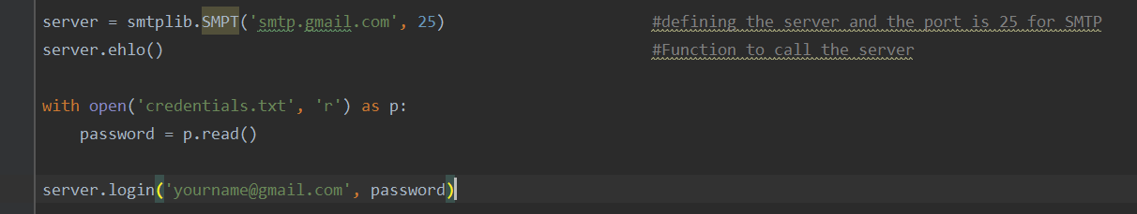

Then defined the header, which consists of a FROM, TO & SUBJECT. The message.txt file is created in the same directory and it’ll be read and attached as a plain text.

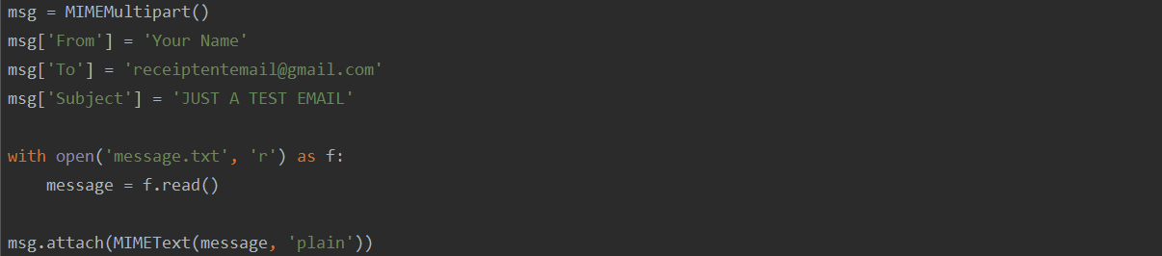

Next, the image will be read in bytes format and octet-stream is the processing the image data in payload. Followed by encoding the payload with header. Converting full msg as string and sending the message as text.

